Ex.no:7.b | DATA VISUALIZATION USING TABLEAU

Aim:
To connect, analyze, visualize, and create interactive dashboards using Tableau for effective business intelligence and data analytics
Algorithm :
Connecting Data Source
Step 1 Open Tableau Desktop
Step 2 Select Connect
Step 3 Choose Excel File
Step 4 Browse Dataset
Step 5 Open Dataset
Step 6 Verify Imported Data

Algorithm – Sheet 1: Age vs Blood Pressure by Gender
Chart: Bar chart
- Open the medical dataset in Tableau.
- Create a new worksheet named Sheet 1.
- Drag Blood Pressure to the Columns shelf.
- Drag Age to the Rows shelf.
- Tableau automatically aggregates Age using SUM(Age).
- Drag Gender to the Color property.
- Select Automatic/Bar chart.
- Compare the age distribution across different blood-pressure categories.
- Use the color legend to distinguish male and female records.
- Analyze the relationship between Age, Blood Pressure, and Gender.

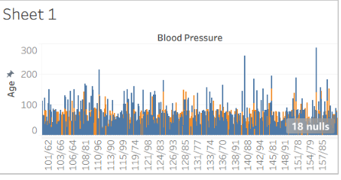
Algorithm – Sheet 2: Age vs Blood Sugar by City
Chart: Line chart
- Create a new worksheet named Sheet 2.
- Drag Blood Sugar to the Columns shelf.
- Drag Age to the Rows shelf.
- Tableau calculates SUM(Age) and SUM(Blood Sugar).
- Drag City to Color.
- Select the Line chart from the Show Me panel.
- Generate separate colored lines for different cities.
- Compare blood-sugar values with age across cities.
- Identify cities showing higher or lower blood-sugar patterns.
- Use the visualization to understand the relationship between Age, Blood Sugar, and City.
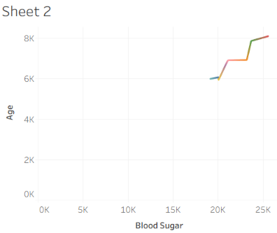

Algorithm – Sheet 3: Age Distribution
Chart: Histogram / Bar chart
- Create a new worksheet named Sheet 3.
- Select the Age field.
- Create Age Bins to group patients into age ranges.
- Place Age (bin) on the Columns shelf.
- Place Age on the Rows shelf.
- Change the aggregation to COUNT(Age).
- Select the Bar chart.
- Display the number of patients in each age group.
- Compare the frequency of different age ranges.
- Identify the age group having the highest number of patients.
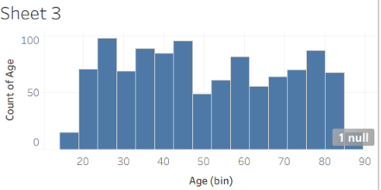
Algorithm – Sheet 4: Blood Pressure by Age Group
Chart: Bar chart
- Create a new worksheet named Sheet 4.
- Create Age Bins from the Age field.
- Drag Age (bin) and Age to the Columns shelf.
- Drag Blood Pressure to the Rows shelf.
- Use Measure Names to compare the selected measures.
- Select the Bar chart.
- Apply different colors using Measure Names.
- Display blood-pressure categories for different age groups.
- Compare blood-pressure patterns across age ranges.
- Identify which age groups contain different blood-pressure levels.
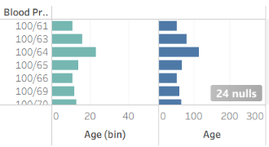
Algorithm – Sheet 5: Age and Blood Sugar by Smoking Status
Chart: Line chart
- Create a new worksheet named Sheet 5.
- Drag Blood Pressure to the Columns shelf.
- Drag Smoker to the Rows shelf.
- Add Age and Blood Sugar as measures.
- Use Measure Names to display multiple measures.
- Select the Line chart.
- Apply color based on Measure Names.
- Compare Age and Blood Sugar across blood-pressure categories.
- Analyze differences between smokers and non-smokers.
- Identify patterns among Smoking Status, Age, Blood Sugar, and Blood Pressure.
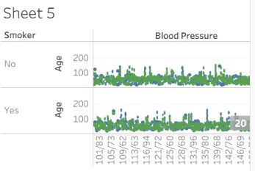
Algorithm – Sheet 6: BMI by Gender
Chart: Automatic chart
- Create a new worksheet named Sheet 6.
- Drag Gender to the Rows shelf.
- Drag BMI to the Columns shelf.
- Tableau calculates SUM(BMI).
- Keep the chart type as Automatic.
- Display BMI values separately for each gender.
- Compare the BMI distribution between genders.
- Identify which gender has a higher or lower aggregated BMI.
- Add labels or filters if required.
- Interpret the relationship between Gender and BMI.
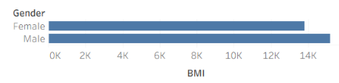

Result:
Thus the tabelu experiment was successfully executed

